**Step 1: -** Take the snapshot of the eCare database and UCM Database using “co-uk-app-run-rpm-p” pipeline by creating a new release and run the “Live RDS Snapshot Backup” Stage.

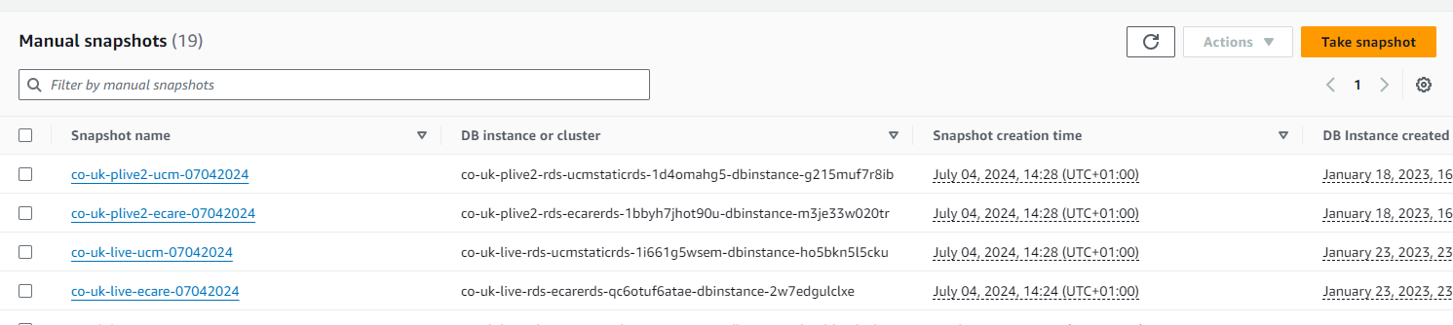

Check manually in AWS whether backup

**Step 2: -** Note the existing build number and release number for dynamic- WCC and eCare - WCC and WCP, Reverse proxy and web layer, Coherence

eCare Admin: -

++++++++++++++

BuildNumber: 1799785

Release: 315809

------------------------------------------

eCare WCP/WCC: -

++++++++++++++

BuildNumber: 1799785

Release: 315810, 315809

----------------------------------------------

UCM Static WCC/Admin: -

++++++++++++++

BuildNumber: 1799785

Release: 315810, 315809

-------------------------------------------------

Coherence Proxy/Admin: -

++++++++++++++

BuildNumber: 1799785

Release: 315810

--------------------------------------------------

Coherence Cache: -

++++++++++++++

BuildNumber: 1799785

Release: 315810

----------------------------------------------

Reverseproxy::-

Buildnumber:- 315810

Release:-1799785, 315809

weblayer:-

Buildnumber:- 1799785

Release:- 315809

+++++++++++++++++++++++

wcc-4  
wcp -7  
ucm -10  
coherence cache -5  
RP -14  
coherence procy 4  
Weblayer-12

**Step 3: -** Note down the AMI id() older and Newer

New: ami-0e6d184469432d53f

Old: ami-0a8709620f5de99f4

**Step 4: -** Check the Code in the REPO of Apache versions was updated or not

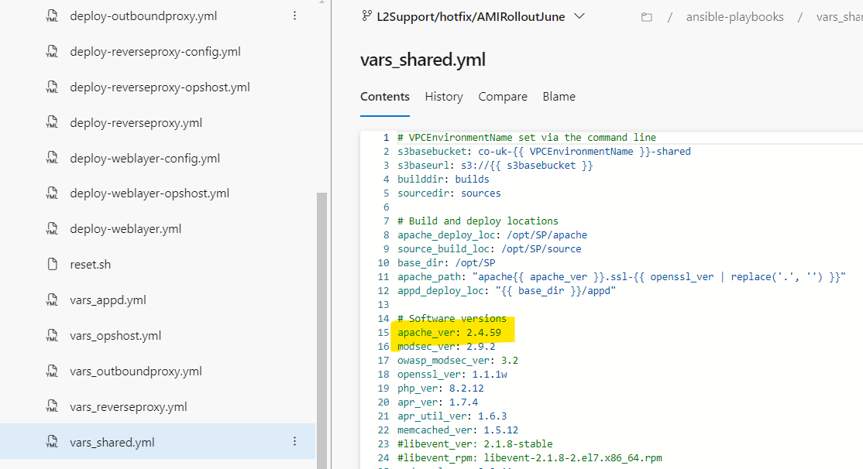

**Step 5: -** Change the AMI id in the variables in “Image id” and template values as True and False State for both template A and B.

**Step 6: -** Build the Code and Create the release under AMI- Automation- pipeline

**#1943338 • Merged PR 219408: Merge L2Support/hotfix/AMIRolloutJune into release/latest/6.1.0**

First release: https://vfuk-digital.visualstudio.com/Digital/_releaseProgress?releaseId=321989&_a=release-pipeline-progress

Second release: https://vfuk-digital.visualstudio.com/Digital/_releaseProgress?releaseId=321990&_a=release-pipeline-progress

**Step 7: -** Raise the Partial My Account ACL Holding pages at 07/05/2024 12:40 of co-uk holding page for WCP “www_maintenance.myvodafone_CRQ” during the time of coherence deployment.

**Step 8: -** Deploy first In Reverseproxy and Weblayer servers, once all servers came up and running with new image id **[First Release]**

**Step 9: - [First Release]** changing the template A value as “False” and template B as “False” and create a new release under AMI- Automation- pipeline and deploy in Weblayer and Reverseproxy, it will stop the older servers in AWS console and newer servers come up with latest Ami

**Step 10: -** Deploy in the **[First Release]** in live eCare servers post new servers came up and running stop all the older managed servers of eCare in WebLogic console and delete them

**Step 11: -** In the [**Second release]** the template A value as “True” and template B as “False” deploy the eCare servers and verify the old servers were terminated in AWS or not. **Check the TIL GW certificate and /etc/hosts file content In ecare wcp servers**

172.29.178.118  tilgw-igw02-internal.uk.vodafone.com tilgw-igw02-internal.uk.vodafone.com

**Step 12: -** In the [**First release]** Deploy in the UCM static servers and stop all the older Managed servers in WebLogic console and delete them.

**Step 13: -** In the [**Second release]** deploy the UCM servers and verify the older Managed servers were terminated in AWS or not.

**Step 15: -** In the [**Second release]** deploy the coherence servers and verify the old Managed servers were terminated in AWS or not.

**Step 16: -** Perform the Post Activity using the co-uk-app-run-rpm-p under this stage “Live AMI Post Implementation” and in Coherence Admin server.

Update cache coherence Ips in this PATH in /u01/app/oracle/Coherence_OPT/client-cache-config.xml

And clear the cache from admin server…

**Step 17: -** Check for latest build & success message in all the servers.

Check AMI ID (AWS ec2 describe-instances). It should be latest. Check Running status in console for all the servers. Check for metadata import, GPG import (automation)

**Step 18:-** Check the TIL GW certificate and /etc/hosts file content

In ecare wcp servers

**Step 19: -** Lower the COUK Holding page at 07/05/2024 4:40

**Step 20: -** Check the Internal sanity and handover DVT at 3:00 AM BST

**Step 21:-** Close the CRQ in ITSM Portal

GPG key import?  
need to update in all wcp servers using ssm   
sudo su - oracle -c "gpg --list-keys"

sudo su - oracle -c "gpg --import /u01/app/oracle/domains/webcenter_live/wrpCodeDist/VF_PROD_public.key"

Logs files ---

~~4 servers left (build host ,bastion ,etl and ops box) : done~~

eCare- WCC:

===========

ip-172-29-179-31_wcc

ip-172-29-179-83_wcc

ip-172-29-180-190_wcc

ip-172-29-181-197_wcc

eCare- WCP:-

===========

ip-172-29-178-191_wcp

ip-172-29-178-192_wcp

ip-172-29-178-50_wcp

ip-172-29-179-224_wcp

ip-172-29-181-24_wcp

ip-172-29-181-65_wcp

ip-172-29-181-83_wcp

UCM static:-

==============

ip-172-29-178-105_wcc

ip-172-29-178-55_wcc

ip-172-29-179-126_wcc

ip-172-29-179-127_wcc

ip-172-29-179-163_wcc

ip-172-29-180-189_wcc

ip-172-29-180-57_wcc

ip-172-29-181-164_wcc

ip-172-29-181-232_wcc

ip-172-29-181-43_wcc

Coherece Cache:-

===============

ip-172-29-178-21_coh

ip-172-29-178-231_coh

ip-172-29-179-175_coh

ip-172-29-181-221_coh

ip-172-29-181-244_coh

Cohernce Proxy:-

================

ip-172-29-179-106_proxy

ip-172-29-179-168_proxy

ip-172-29-181-243_proxy

ip-172-29-181-7_proxy